
MENOFYIA UNIVERSITY جامعة المنوفية SYSTEM ANALYSIS & DESIGN PROJECT كلية الحاسبات والمعلومات
SECOND YEAR 2027-2026
2027-2026

Scholarship Application & Approval System

No. | Name | Section
1 | Marwa Sabry Ahmed | 1

Planning (Project Plan)

Project Identification

​Project Name:
​
Scholarship Application & Approval System
​

Current Problem:
​
1-Difficulty in finding suitable scholarships easily.
​2-Manual and disorganized tracking of application deadlines and requirements.
​3-High risk of losing paper documents or missing submission dates.
​4-Lack of a centralized platform to check scholarship status and approvals.
​

Description about Project:
.The system helps students easily find and apply for various
scholarships by filtering through categories, deadlines, and fields of study. It enables users to submit required documents online, track their application status in real-time, and receive automated notifications. The system reduces paperwork, saves time, minimizes errors, and provides administrators with an efficient way to review applications and manage approvals smoothly
System Request
System Request-Scholarship Application
Project Sponsor: | Marwa
Business Need: | 1-Simplify the scholarship search and application process.  ​2-Dispense with paper-based submissions.  ​3-Make scholarship opportunities accessible to all eligible students.  ​4-Ensure application updates and statuses are available in real-time.
Business Requirements: | ​1-Update system interface and database.  ​2-Provide online application access and document uploads.  ​3-Admin dashboard for reviewing and approving applications.  ​4-Notification system for deadlines and status changes.
Business Value: | ​1-Providing accurate and centralized information.  ​2-Saving time for both applicants and administrators.  ​3-Saving administrative and paper costs.  ​4-Saving physical and manual effort.
Special Issues or Constraints: | ​1-Strict deadlines for scholarship submissions.  2-Constantly updating scholarship availability and requirements.

Feasibility Analysis
​
-The system will be user-friendly, requiring minimal training for students and administrators. It solves current bottlenecks and has full support from project stakeholders.
​
Schedule Feasibility: Technical Feasibility:
​
-The project is technically feasible. We will use standard web technologies (HTML, CSS, JavaScript, PHP, and MySQL database) which are well-supported, and the development team already has the necessary technical skills to implement them.
​
Economic Feasibility (Cost-Benefit Analysis):
​
1-Development Costs: Low, as open-source tools and existing hardware resources are used.

2- Operational Costs: Minimal maintenance overhead.
​
3- Benefits: Substantially reduces administrative workload, paper expenses, and processing time for student applications.
​
Operational Feasibility:
​
-The project timeline is well-structured and realistic, with dedicated milestones for planning, design, implementation, and testing to ensure delivery before the deadline.
Time Estimation

 | Planning | Analysis | Design | Implementation
Standard  percentages | 15% | 20% | 35% | 30%
Estimated time based on planning time | Actual:11 days | 16 days | 25 days | 22 days

Task Identification
Name of Task | System Request
Start Date | 01/10/2026
End Date | 04/10/2026
Person assigned to task | Marwa Sabry
Priority | High
Resources Needed | Microsoft Word
Estimated Time | 4 hours
Actual Time | 2 hours

Name of Task | Feasibility Study
Start Date | 04/10/2026
End Date | 09/10/2026
Person assigned to task | Marwa Sabry
Priority | High
Resources Needed | Microsoft Word
Estimated Time | 8 hours
Actual Time | 5 hours

Name of Task | Pert Chart, Gantt Chart
Start Date | 09/10/2026
End Date | 11/10/2026
Person assigned to task | Marwa Sabry
Priority | High
Resources Needed | Microsoft Project
Estimated Time | 9 hours
Actual Time | 6 hours

Name of Task | Interview
Start Date | 11/10/2026
End Date | 16/10/2026
Person assigned to task | Marwa Sabry
Priority | Medium
Resources Needed | Microsoft Project
Estimated Time | 16 hours
Actual Time | 14 hours

Name of Task | Questions
Start Date | 16/10/2026
End Date | 20/10/2026
Person assigned to task | Marwa Sabry
Priority | Medium
Resources Needed | Form drive
Estimated Time | 5 hours
Actual Time | 2 hours

Name of Task | Data Flow Diagram
Start Date | 21/10/2026
End Date | 26/10/2026
Person assigned to task | Marwa Sabry
Priority | High
Resources Needed | Internet
Estimated Time | 1 day
Actual Time | 18 hours

Name of Task | Data Store
Start Date | 26/10/2026
End Date | 29/10/2026
Person assigned to task | Marwa Sabry
Priority | High
Resources Needed | Microsoft Word
Estimated Time | 1 day
Actual Time | 17 hours

Name of Task | Process Specification
Start Date | 26/10/2026
End Date | 30/10/2026
Person assigned to task | Marwa Sabry
Priority | High
Resources Needed | Microsoft Word
Estimated Time | 1 day and 10 hours
Actual Time | 19 hours

Name of Task | Entity Relationship
Start Date | 29/10/2026
End Date | 5/11/2026
Person assigned to task | Marwa Sabry
Priority | High
Resources Needed | StarUML
Estimated Time | 1 day and 10 hours
Actual Time | 19 hours

Name of Task | Normalization
Start Date | 29/10/2026
End Date | 5/11/2026
Person assigned to task | Marwa Sabry
Priority | High
Resources Needed | StarUML
Estimated Time | 1 day and 10 hours
Actual Time | 19 hours

Name of Task | design
Start Date | 6/11/2026
End Date | 1/12/2026
Person assigned to task | -
Priority | High
Resources Needed | Visual Studio Code
Estimated Time | 18 days
Actual Time | 13 hours

Name of Task | Implementation
Start Date | 1/12/2026
End Date | 23/12/2026
Person assigned to task | Marwa Sabry
Priority | High
Resources Needed | Visual Studio Code
Estimated Time | 16 days
Actual Time | 11 days

Pert Chart (MS-Project)
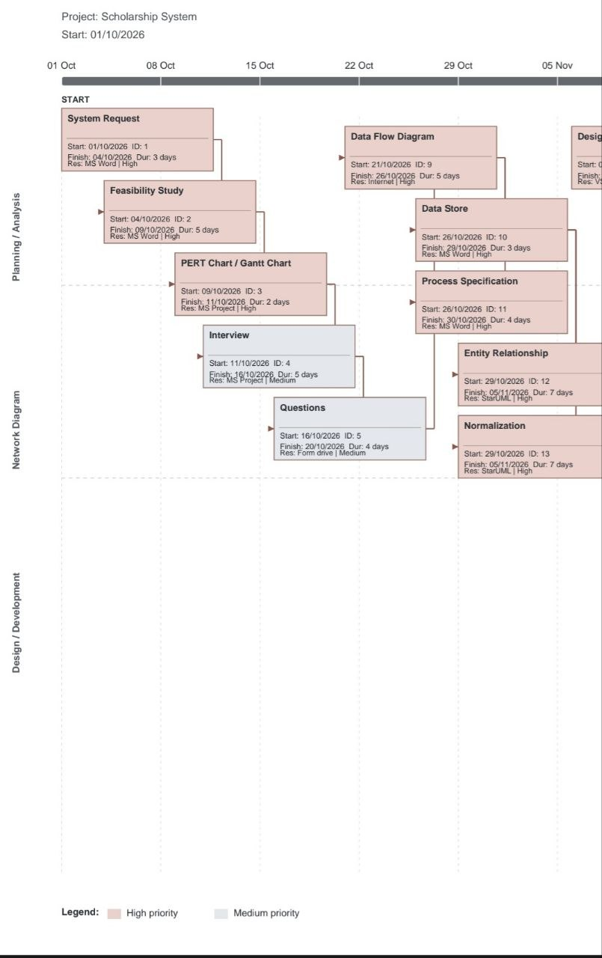

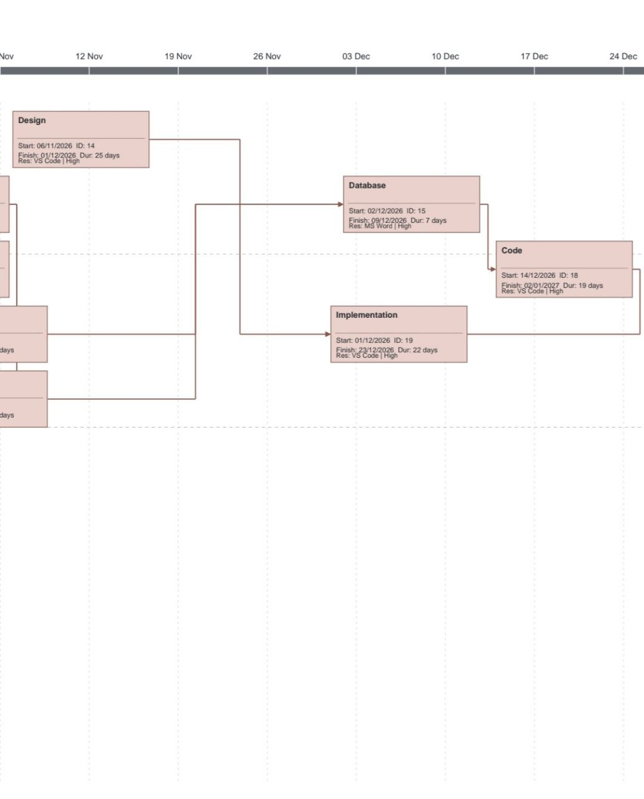
Gantt Chart (MS-Project)
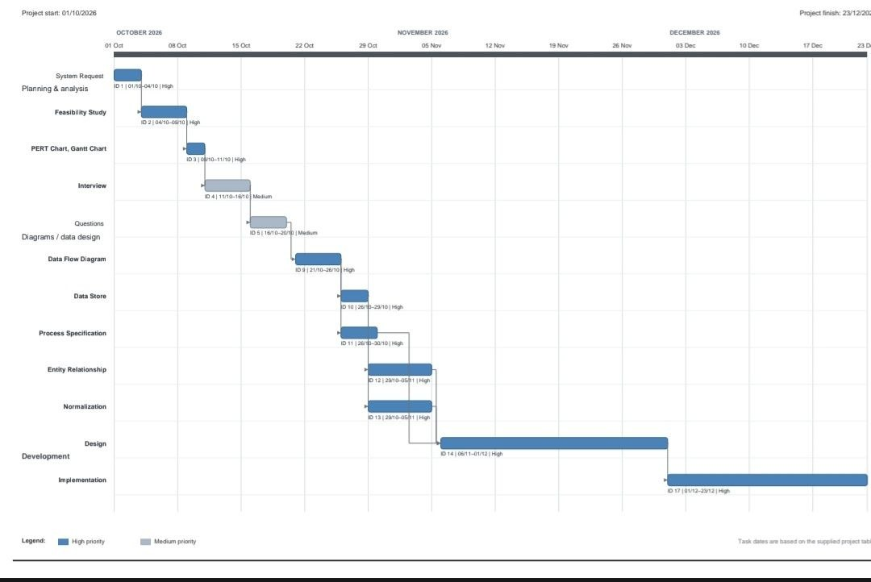

Analysis (Project proposal)

Interview
(include questions and answers)
​1) What is your opinion of the current state of the scholarship application process?
​Answer: I think it is inefficient and very slow. Applications are collected manually on paper and via scattered emails, which causes major delays and loss of student documents.
​2) How does the current system work, and what are its main procedures?
​Answer: Students submit hard copies of their certificates and ID documents to the office. The committee then manually logs each student into Excel sheets, calculates scores, and posts the accepted lists on bulletin boards.
​3) What are the common errors and problems in the current system?
​Answer: Loss of student documents, lack of application privacy, calculation errors in eligibility scoring, and extreme delay in announcing scholarship results.
​4) How do users feel when interacting with the current system?
​ Answer: Students feel frustrated and anxious because they cannot track their application status. Committee members feel overwhelmed and exhausted due to excessive manual data entry and review.
​5) What are the critical objectives and recommendations for the new system?
​Answer: We need an automated web portal with role-based security, live application tracking, automated document validation, and email notifications for students.
​
​6) Is the current scholarship system easy to use?
​Answer: No, the system is difficult to navigate and requires physical attendance at the office.
​7) What is the primary method currently used to archive student applications? (Choose Question)
​[ ] A) Centralized Database
​[x] B) Paper files and separate Excel spreadsheets
​[ ] C) Cloud Storage Drive
​[ ] D) No archiving system used
​Answer: B) Paper files and separate Excel spreadsheets.
​8) Which user group causes the highest administrative bottleneck in the current workflow? (Choose Question)
​[ ] A) High GPA applicant screening
​[x] B) Verification of income & supporting financial documents
​[ ] C) System administrator setup
​[ ] D) Final dean sign-off
​Answer: B) Verification of income & supporting financial documents.
​9) Does the current system allow students to track their application status online in real-time?
​Answer: No, there is no real-time status tracking feature available.
​10) Will the proposed automated web system significantly reduce application processing time?
​Answer: Yes, it will automate eligibility calculations and drastically speed up the review cycle.

Interview Report

Person Interviewed: Dr. Osama (Scholarship Office Director)
Interviewer: Marwa Sabry (System Analyst)
Purpose of Interview:
1. To see how the current scholarship process works and analyze its bottlenecks.
2. Take advantage of existing administrative workflows and address current errors
3. Identify essential system tools and determine how they will be developed.
Summary of Interview:
- The current system relies on paper folders and unlinked spreadsheets.
- Common errors include loss of confidential student documents and scoring errors.
- The current system lacks security, data privacy, and centralized backup.
Open Items:
- Minimum 4 committee members needed for multi-level approval workflows.
- Create a responsive web portal to make the application process fast for students|
- Develop an admin dashboard to make student evaluation and filtering easy.
Detailed Notes: See attached transcript.

Interview Report

Person Interviewed: Ahmed (Student / Scholarship Applicant)

Interviewer: Marwa Sabry (System Analyst)

Purpose of Interview:

- Understand user experience and difficulties faced during application.
2. Evaluate student satisfaction with current submission channels.
3. Identify desired user features for the upcoming online portal.
Summary of Interview:

- Students must physically visit the office or email files with no delivery proof.
- Students face extreme anxiety due to lack of application status updates.
- Strong preference for a clean web interface accessible via mobile devices.
Open Items:
- Implement real-time status tracker (Submitted -> In Review -> Accepted/Rejected)
- Build automated document upload validation (PDF/JPG format & size checks).
- Send automated email notifications upon status changes.
Detailed Notes: See attached transcript.

Questionnaire & Responses
